Module 1 — Introduction to Mastering LLMs & APIs

Goal: Learn to talk to almost any AI model (GPT-4o, Claude, Gemini, Llama, DeepSeek, Grok, Mistral, Qwen and many more) using clean, smart code that lets you switch models with basically one line — without rewriting your entire app every time.

Why should we learn this?
In 2026 the LLM world changes every few months. Prices go up, new models drop, companies change rules, and suddenly your perfect GPT-4o code stops being the best choice.

Real situations you will face (and I’ve seen hundreds of developers hit this wall):
- Your boss says “Switch to Claude, it’s safer for our data and cheaper now.”
- OpenAI increases prices again → you want to jump to Groq + Llama or DeepSeek instantly.
- You built something amazing with GPT-4o → now you want to test the same logic with Gemini 2.0 (huge context) or Grok for fun.
- You need tools (search Google, check your shop database, send emails) but every model handles function calling differently.
- You want the AI to remember your regular Bhopal customers (“Raman always wants fast delivery”).

If your code is locked to only one company (like OpenAI), every change becomes painful and expensive. We learn to write code once → then switch models, add tools, memory, or fallback to cheaper options with almost zero effort.

Different types of LLMs you’ll meet in 2026
There are four main types of LLMs right now. Knowing them helps you choose the right one for the job:
- Proprietary / Closed-source models (Best quality, paid API)
  - OpenAI GPT-4o & o1 series: King of reasoning and complex tasks. Expensive but smartest overall. Great for coding, math, and careful thinking.
  - Anthropic Claude 3.5 Sonnet / Claude 4: Amazing at writing, coding, and following instructions safely. Very long context (200k tokens). Many people say it feels “more thoughtful”.
  - Google Gemini 1.5 / Gemini 2.0: Insane context window (up to 1–2 million tokens). Best when your document or chat history is huge. Also excellent with images and video.
- Open-weight / Open-source models (Free or cheap, run anywhere)
  - Meta Llama 3.1 / Llama 4 (70B or 405B): Extremely popular. Very strong reasoning. You can run them on Groq, Together.ai, or even locally.
  - DeepSeek-V3 / DeepSeek-R1: Crazy cheap and surprisingly smart, many people use it as daily driver now.
  - Mistral Large / Mixtral: European models, very good at multilingual (Hindi + English) and fast.
- Fast Inference Providers (Speed kings)
  - Groq: Super-fast chips. Llama or DeepSeek runs 5–10× faster than normal. Perfect for chatbots and real-time replies.
  - Together.ai / Fireworks.ai: Great prices and fast. Good for running open models cheaply.
- Local / Private models (No API cost, runs on your laptop)
  - Use Ollama to run Llama 3.1, Mistral, or Phi-3 completely offline.
  - Perfect for sensitive data (medical, legal, or your shop customer info) because nothing leaves your computer.

Each type has different strengths, speed, cost, intelligence, safety, context length. The beauty of this course? You’ll write code that can use any of them with one single change.

Lets look into Some real life situation
You run a mobile repair shop near New Market. Every day you get WhatsApp messages:
You want an AI that:
- Replies politely in Hindi + English
- Checks price and stock automatically
- Books repair slot
- Remembers “Raman prefers original Samsung parts and fast delivery”

Next month your friend says “Bhai, use this new DeepSeek model — it’s 10× cheaper.” With our unified code, you just change model="groq/llama-3.1-70b-versatile" to model="deepseek/deepseek-chat", done. No rewriting, no headache.

What we'll actually build step by step
We’re going to build this like a game with clear levels:
- Connect to any model with one clean function
- Force perfect JSON output every single time
- Add tools (calculator, search, your database, email)
- Add short-term memory (remembers the whole conversation)
- Add long-term memory (remembers customer preferences forever)
- Handle rate limits, automatic retries, and smart fallbacks
- Combine everything into real apps (shop assistant, research helper, email writer, personal agent)

Quick look at how modern AI agents work
Most powerful systems follow this pattern:
(LLM in the middle + Memory + Tools + Planning loop)
And for remembering important facts forever:
(Vector memory for long-term knowledge)
This is exactly what top companies and smart developers use in 2026.

Big benefits you get after this module
- One codebase that works with 100+ models
- Switch between expensive smart models and cheap fast ones instantly
- Never get stuck when prices change or new models launch
- Build future-proof apps that can use the best model available at any time

Outcome
Reader understands: • why writing model-specific code is painful and risky in 2026 • the four main types of LLMs (proprietary, open-weight, fast inference, local) and when to use each • the huge advantage of learning unified LLM access • exactly what powerful real-world things we’ll build together

Module 2: Mastering LLMs & APIs – Connect to Any Model, Add Tools & Memory

Goal
- Write code once → talk to GPT-4o / Claude 4 / Gemini 2 / Llama 4 / DeepSeek / Grok etc.
- Send structured requests → get reliable JSON/tool calls
- Add tools (search, calculator, your shop database)
- Add memory (remembers customers)
- Handle rate limits, retries, cheap fallbacks
Build production-ready agents without rewriting code every time prices change or a new model drops.

Why this really matters nowadays:
Your shop gets 20–30 WhatsApp messages/day:
"Screen tod gaya bhaiya, kitna time lagega?"
You reply manually → slow + tired.
The AI replies politely in Hindi/English, checks price/stock, books slot, remembers "Raman prefers Samsung parts", switches to cheaper DeepSeek when busy.

1. Setup (Do Once – 5 Minutes)

Install core libs:

pip install litellm python-dotenv pydantic langchain langchain-community chromadb requests tenacity

Create .env file in your project folder (never commit to git!):
OPENAI_API_KEY=sk-...
ANTHROPIC_API_KEY=sk-ant-...
GEMINI_API_KEY=AIza...
GROQ_API_KEY=gsk_...
TOGETHER_API_KEY=...
# Add more as needed (DeepSeek, Fireworks etc.)

Load them safely:
from dotenv import load_dotenv
load_dotenv()

Get free keys today:
- OpenAI → platform.openai.com
- Anthropic → console.anthropic.com
- Google Gemini → ai.google.dev
- Groq (fast open-source) → console.groq.com
- Together.ai / Fireworks.ai for more open models

2. Core Idea: Unified LLM Caller (Write Once, Switch Forever)

LiteLLM makes 100+ models look like OpenAI format.
# llm.py – your central file
from litellm import completion
import os

def ask_llm(
prompt_or_messages,
model="openai/gpt-4o-mini", # ← change ONLY here!
temperature=0.7,
max_tokens=500,
tools=None, # for function calling later
response_format=None # for structured JSON
):
if isinstance(prompt_or_messages, str):
messages = [{"role": "user", "content": prompt_or_messages}]
else:
messages = prompt_or_messages

try:
response = completion(
model=model,
messages=messages,
temperature=temperature,
max_tokens=max_tokens,
tools=tools,
response_format=response_format,
api_key=os.getenv(f"{model.split('/')[0].upper()}_API_KEY") # auto picks key
)
return response.choices[0].message
except Exception as e:
print(f"Error with {model}: {e}")
return None

Test it:
msg = ask_llm("One fun fact about Bhopal?")
print(msg.content)

Now change model= to:
- "anthropic/claude-3-5-sonnet-20241022" (or newer Claude 4 variants)
- "gemini/gemini-1.5-flash" (or gemini-2.0)
- "groq/llama-3.1-70b-versatile" (super fast)
- "deepseek/deepseek-chat" (cheap reasoning)
Same code — different brain. That's the win.
Here’s a visual of what this unification looks like in practice:
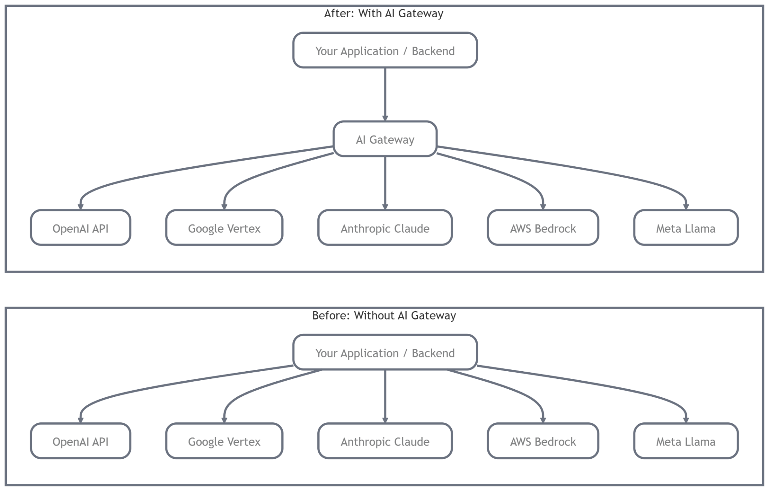

3. Structured Outputs – Guaranteed JSON (No More Parsing Mess)

Use Pydantic + response_format.
from pydantic import BaseModel, Field

class RepairReply(BaseModel):
greeting: str = Field(description="Polite hello in Hindi+English")
model_ask: str = Field(description="Ask for phone model if missing")
price_quote: str | None = None
slot_suggest: str | None = None

response = ask_llm(
"Customer: Screen broken. Reply helpfully.",
model="openai/gpt-4o-mini",
response_format={"type": "json_schema", "json_schema": RepairReply.model_json_schema()}
)

print(response.content) # valid JSON every time

Claude/Gemini support similar via tools or json mode.

4. Tool / Function Calling (AI Uses Calculator, Search, Your APIs)

Define tools like OpenAI format (LiteLLM normalizes for all).
tools = [
{
"type": "function",
"function": {
"name": "get_current_price",
"description": "Get repair price for phone model",
"parameters": {
"type": "object",
"properties": {"model": {"type": "string"}},
"required": ["model"]
}
}
},
{
"type": "function",
"function": {
"name": "book_slot",
"description": "Book repair slot for customer",
"parameters": {
"type": "object",
"properties": {
"customer_name": {"type": "string"},
"time": {"type": "string"}
},
"required": ["customer_name", "time"]
}
}
}
]

# In ask_llm pass tools=tools

Loop example (simple ReAct-style agent):
def run_agent(query, model="groq/llama-3.1-70b-versatile"):
messages = [{"role": "user", "content": query}]
while True:
resp = ask_llm(messages, model=model, tools=tools)
messages.append(resp)

if not hasattr(resp, 'tool_calls') or not resp.tool_calls:
return resp.content # final answer

for tool_call in resp.tool_calls:
func_name = tool_call.function.name
args = json.loads(tool_call.function.arguments)

if func_name == "get_current_price":
# fake db call
result = f"₹{1500 if 'samsung' in args['model'].lower() else 2000}"
elif func_name == "book_slot":
result = f"Slot booked for {args['time']}"
else:
result = "Tool not found"

messages.append({
"role": "tool",
"tool_call_id": tool_call.id,
"name": func_name,
"content": result
})

print(run_agent("Fix my iPhone screen tomorrow morning?"))

This flow (very common agent pattern):
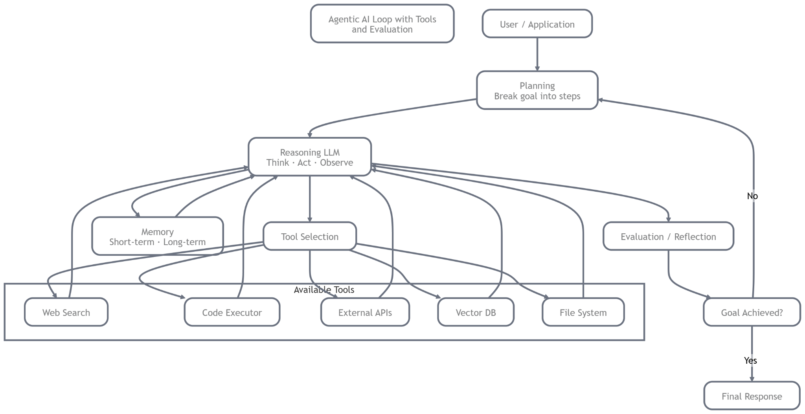

5. Memory Integration
Short-term (conversation history):
Use list of messages — just keep appending.
Long-term (persistent facts, customer prefs) – use Chroma vector store + RAG.
from langchain_community.vectorstores import Chroma
from langchain_openai import OpenAIEmbeddings # or use free HuggingFace embeddings

embeddings = OpenAIEmbeddings()
vectorstore = Chroma("shop_memory", embeddings)

# Save fact
vectorstore.add_texts(["Raman prefers fast delivery and Samsung parts."])

# Retrieve before asking LLM
docs = vectorstore.similarity_search(query, k=3)
context = "\n".join([d.page_content for d in docs])

full_prompt = f"Context from memory:\n{context}\n\nUser: {user_query}"

Short V/S Long Memory:
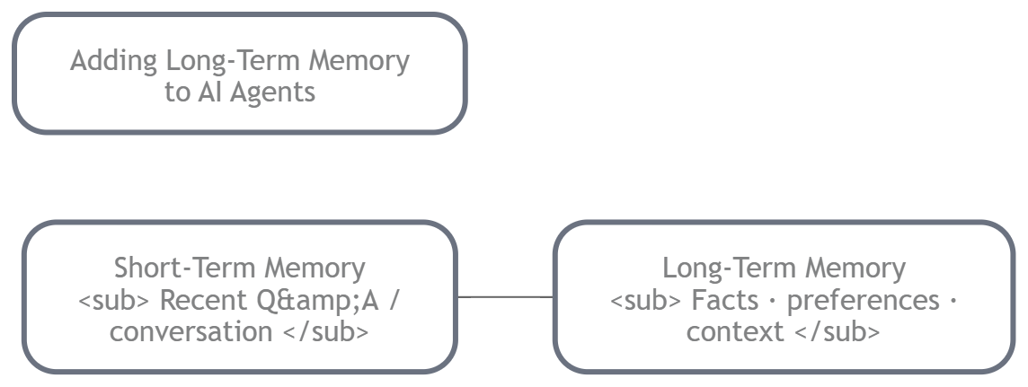

6. Rate Limits, Retries, Fallbacks & Cost Optimization

Use tenacity for retries:
from tenacity import retry, stop_after_attempt, wait_exponential

@retry(stop=stop_after_attempt(5), wait=wait_exponential(multiplier=1, min=2, max=10))
def safe_ask_llm(...):
...

Fallback routing:
models_to_try = [
"openai/gpt-4o-mini",
"groq/llama-3.1-70b-versatile",
"deepseek/deepseek-chat"
]

for m in models_to_try:
try:
resp = ask_llm(..., model=m)
if resp: return resp
except:
continue
Current rough pricing/context (March 2026 snapshot):
- GPT-4o family: ~$0.15–$2.50 input / $0.60–$10 output, 128k–1M context
- Claude 4 variants: ~$3–$15 / M tokens, 200k context
- Gemini 2.x: ~$0.30–$10, up to 1M+ context
- Groq Llama/DeepSeek: 10–50× cheaper, 128k–2M context on some

7. Putting It All Together: Mini Shop Agent Example

Combine everything:
# shop_agent.py
def shop_agent(user_query):
# Retrieve long-term memory
docs = vectorstore.similarity_search(user_query, k=2)
memory_ctx = "\n".join(d.page_content for d in docs) or "No prior info."

system = f"You are helpful repair shop assistant in Bhopal. Use Hindi+English. Memory: {memory_ctx}"

messages = [{"role": "system", "content": system}, {"role": "user", "content": user_query}]

final = run_agent(messages, model="groq/llama-3.1-70b-versatile") # cheap & fast fallback
return final
Run: print(shop_agent("My Samsung screen cracked, book slot?"))

Bonus: Local / Open-Source (No API Cost)
Use Ollama for fully local:
# Install Ollama → ollama.com
ollama run llama3.1
Then in LiteLLM: model="ollama/llama3.1"
Or Groq for free/fast inference.

